Second

## R Markdown

This is an R Markdown document. Markdown is a simple formatting syntax for authoring HTML, PDF, and MS Word documents. For more details on using R Markdown see <http://rmarkdown.rstudio.com>.

When you click the **Knit** button a document will be generated that includes both content as well as the output of any embedded R code chunks within the document. You can embed an R code chunk like this:

summary(cars)

## speed dist   
## Min. : 4.0 Min. : 2.00   
## 1st Qu.:12.0 1st Qu.: 26.00   
## Median :15.0 Median : 36.00   
## Mean :15.4 Mean : 42.98   
## 3rd Qu.:19.0 3rd Qu.: 56.00   
## Max. :25.0 Max. :120.00

library(stringi)  
x <- 8  
x+10

## [1] 18

print(x)

## [1] 8

x <- x*10  
print(x)

## [1] 80

n <- 100  
t <- seq(0,2*pi, length.out = n)  
  
x <- 16*sin(t)**3  
y <- 13*cos(t)-5*cos(2*t)-cos(3*t)-cos(4*t)  
plot(x,y, type="l", asp = 1)

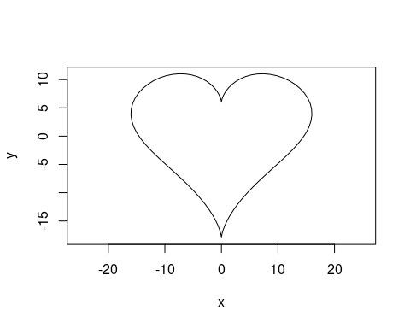

|  |  |  |  |  |
| --- | --- | --- | --- | --- |
| Sepal.Length | Sepal.Width | Petal.Length | Petal.Width | Species |
| 5.1 | 3.5 | 1.4 | 0.2 | setosa |
| 4.9 | 3.0 | 1.4 | 0.2 | setosa |
| 4.7 | 3.2 | 1.3 | 0.2 | setosa |
| 4.6 | 3.1 | 1.5 | 0.2 | setosa |
| 5.0 | 3.6 | 1.4 | 0.2 | setosa |

## Source

source("test.R")

## Wykonanie source

f(2,4)

## [1] 36

print(runif(1))

## [1] 0.2315654

## Eksperyment

N <- 10000000  
x <- runif(N)  
mean(x)

## [1] 0.5001078

mean(x)

## [1] 0.5001078

## Błędy

source("ten_nie_istnieje")  
print(6)

source("ten_nie_istnieje")

## Warning in file(filename, "r", encoding = encoding): cannot open file  
## 'ten_nie_istnieje': No such file or directory

## Error in file(filename, "r", encoding = encoding): cannot open the connection

print(6)

## [1] 6

## Including Plots

You can also embed plots, for example:

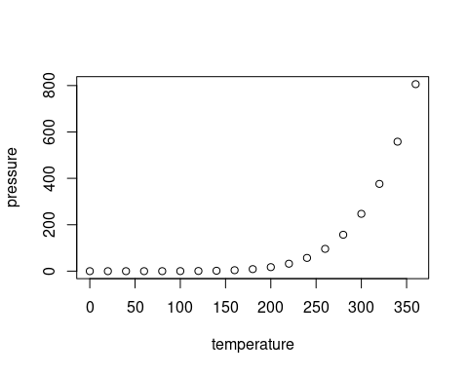

Note that the echo = FALSE parameter was added to the code chunk to prevent printing of the R code that generated the plot.